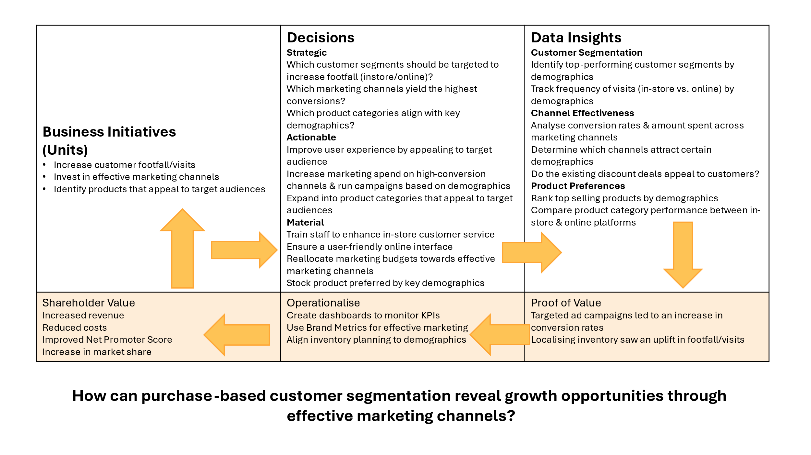

National Health Services (NHS), a publicly funded healthcare system in England has contacted the Data Analytics team to extract meaningful insights from the internal & external data provided to extract utilisation trends of each component in its network in order to answer their business decisions of whether to expand its infrastructure and resources to match its increasing population capacity & hence budget correctly or whether the other set of stakeholders who feel based on current trends utilisation , the current capacity is adequate and only suggestions/recommendations from the available data are required to make better use of existing infrastructure & resources. Therefore, reducing or eliminating missed appointments would be beneficial financially as well as socially. The government needs a data-informed approach to decide how best to handle this problem. At this stage of the project, the two main questions posed by the NHS are:Has there been adequate staff and capacity in the networks? What was the actual utilisation of resources? This project aims to ……

To ensure relevant insights, it’s important to scale the data correctly, account for known reporting gaps, and flag uncertain records. Without this, insights may be skewed and data completeness overstated. In the absence of further metadata, we assume coverage adjustments are accurate, reporting issues are limited to known periods, and ‘Unknown’ labels reliably mark data problems